# Deadlock Avoidance

Applications running on modern day heterogeneous SoCs can generate complex inter-communication messages between the various IP blocks. Such complex, concurrent, multi-hop communication between various cores can result in deadlock situations on the interconnect. Deadlock occurs in a network when messages are unable to make progress to their destination because they are waiting on one another to free up resources, usually buffers and channels. Deadlocks due to blocked buffers can quickly spread over the entire network, paralyzing further operation of the system. Deadlocks can occur both at the network level as well as the protocol level.

NOTE: If NocStudio detects a protocol deadlock that cannot be solved, it notifies the user of the deadlock and the primary cause so architects can fix it by changing their protocol. Finally, NocStudio generates a comprehensive system dependency graph as well so that architects can crosscheck and ensure that there are no deadlocks.

CFG IP is constructed to be deadlock free. It uses graph theory-based approach and formal techniques to ensure that there are no cycles in the entire message dependency chain of the system. Since there are no cycles, there cannot be a deadlock. To achieve this, NocStudio captures the inter-dependencies between various messages and interfaces in the system using a simple specification system. NocStudio then augments it with additional dependency information interpreted from the protocol definition and inferred from system traffic information. The combined dependency specification is used to ensure full deadlock avoidance – both at the network-level and the protocol-level.

## Quick Primer on Deadlocks

A deadlock is a forward-progress issue. A deadlock occurs when two or more operations cannot complete because they are waiting for completion of one of the other operations. Because each operation is waiting for one of the others, none can make progress. The system is deadlocked.

Deadlocks occur when operations need multiple resources to complete, and the different operations acquire those resources in a contradictory order. For example, if operation A and operation B need both resource X and resource Y to complete, they can deadlock if operation A acquires resource X while operation B acquires resource Y. Each operation has half the resources needed to complete, but cannot acquire the remaining resource until the other operation releases it. However, the other operation won’t release the needed resource it until it has acquired both resources.

This deadlock situation can be represented in graphical form showing the resources X and Y and connecting them through dependencies created by the operations. If resource X was acquired by operation A, it cannot be released again until operation A acquires resource Y. There is a dependency between X and Y because of operation A. Similarly, operation B creates a dependency between Y and X. Figure 13 shows the resources and dependencies for this example.



Figure 13. Simple Deadlock Graph with Two Resources

Figure 13 shows a deadlock is possible because of the dependencies’ circular nature. Each first resource can require the second resource be acquired before the first can be released. But the second resource can be acquired by another operation that requires the first be released. The circular nature of these dependencies results in a deadlock.

The interconnect resources are the various buffers or FIFO entries. Packets move from one resource to another in the network, requiring the buffer ahead of it to be available before it can move forward and free up the prior buffer. Deadlocks can occur if the dependencies create a loop.

Figure 14 shows a simple system where two hosts (agents) can issue read requests to the other and receive responses. In this system, the interconnect uses a common buffer pool for all traffic moving in the same direction. Reads or read responses moving from Agent 1 to Agent 0 share the same buffers.



Figure 14. Simple Interconnect with Deadlock

Deadlock can occur where the red arrows indicate a dependency. Here, the dependency is that read requests can complete only when they can issue a read response in the other direction. A deadlock occurs if buffers in both directions are full of read requests and there is no way to send read responses.

## Constructing Deadlock-Free Interconnects

CFG IP achieves full deadlock detection and resolution by partitioning complex protocol transactions into the simpler sub-flows from one endpoint to the next. The subflows are heuristically mapped to virtual channels in a way that the number of global virtual networks remains small. Mapping sub-flows independently decouples the virtual channels used for various regions of a single flow and increases the availability of virtual channels by decreasing the scope of a virtual channel mapping. This strategy is effective even if the total number of virtual channels used globally is fairly small. The deadlock in Figure 14 can be avoided by having separate resources for the read and read-response packets. In that case, read responses can drain, allowing reads to make progress. Adding a virtual channel to the network creates an alternative read-response path through the network.

The order in which sub-flows are processed and mapped to virtual networks is of paramount importance too. Machine learning algorithms are used to automatically learn the correct processing order and converge to an optimal solution quickly. In addition to network level deadlocks, protocol level deadlocks may exist. Protocol deadlocks arise when there is cyclic dependency in the way packets are generated and consumed by the endpoints of the NoC. To detect protocol deadlocks, properties of all system components in terms of how they produce and consume network packets and these packets are inter-related to each other are required. To address this problem, CFG IP uses a simple yet flexible and powerful formal language to capture the deadlock relevant properties of various system components and uses this information to identify and isolate protocol deadlocks. Subsequently this information is also used to construct the network level deadlock-free NoC.

For NocStudio to avoid system deadlocks, it must have accurate information about the dependencies between the traffic flows. If some dependencies are not described or are described incorrectly, the resulting NoC will be incompatible with the hosts connected to it. This will likely cause a system deadlock. In Figure 14, NocStudio must be alerted to the dependency between the host read traffic and the read-response traffic sent in the other direction. NocStudio analyzes the traffic flows and resource dependencies and creates additional virtual channels as required to avoid deadlocks. As shown in Figure 15, NocStudio also generates a comprehensive system dependency graph as well so that architects can crosscheck and ensure that there are no deadlocks.

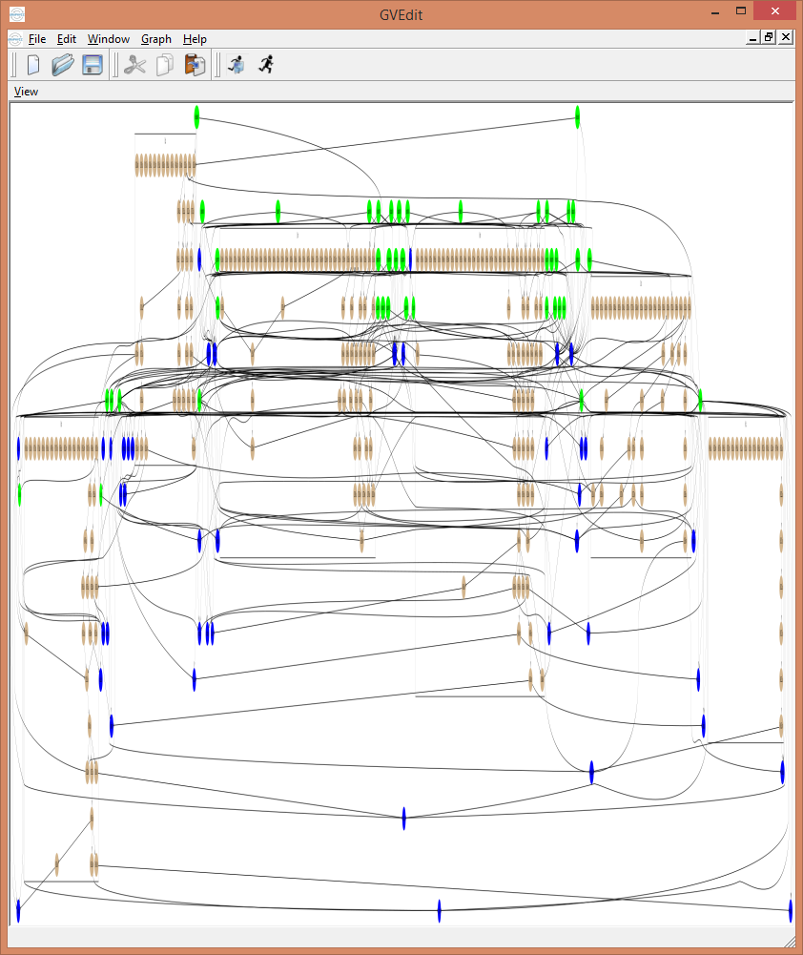

Figure 15 - System Level Dependency Graph

## Protection against Slave dependency behavior

CFG has support for specific slaves that exhibit a dependency between their read and write responses. Specifically, some slaves send write responses in the middle of a multibeat read data response, with the expectation that write response cannot be blocked, and pauses sending the read data until then. This introduces dependency between the channels, and CFG has added support to automatically size the write responses FIFOs to avoid this. This is done by adding a configurable property to the slave bridge, which the user can enabled based on their slave behavior.